Communication
When we are engaging others communication is critical and so we include this short communication tutorial. It essentially underlines the importance of understanding your stakeholders and community residents (Figure 1), internalising the message, stimulating local conversation and establishing norms. It also includes 35 communication channels which are useful for communicating within communities.

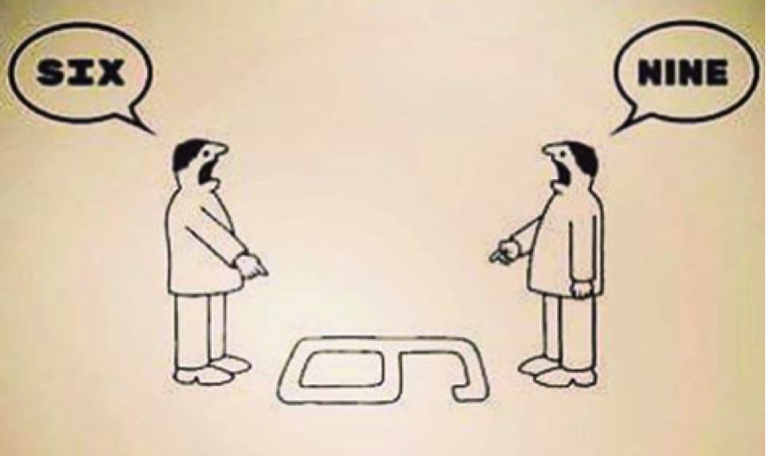

Figure 1: Why can’t you see it’s a 9

Figure 1 shows the importance of understanding the context of those you engage with. We all perceive things in a certain way and one of the chief lessons effective communication teaches is to put yourself in the boots of those you communicate with. Their context has many levels and you need to understand these. There is their physical context – the place they live and reside in, there are also their attitudes, beliefs and the type of people they are. You need to understand where the disadvantages and benefits are for them. Highlight the positives for them in order to motivate them. Think about the disadvantages to them also of engaging in your proposed activities and this will allow you to protect them against these and secure their long term engagement. If you are addressing a group its important to remember that there are very different beliefs within the group and very different understandings to be navigated. Finally, in relation to understanding context and appreciating both sides of the coin you should try to identify and target barriers to change so that you future proof your activities should you engage the stakeholders.

Beyond context the message you use can be made more potent and we briefly review some simple ways to that here. There are some hooks which enable stronger communication and a better chance of engagement. One is internalising your message and making it as relevant to the person or community as possible. This personal or local alinement makes your idea or proposed activity better suit those you wish to engage. Messaging which establishes Norms is extremely powerful and 2 things to bring out here are the physical place and the activities of locals in that place. So a message you should not use in engaging residents in attending a meeting for example for a river clean up is: “please attend the meeting on December 3rd as we really need attendees and helpers to clean up the river”. Instead you could say: “we would like to thank all of those in our community for helping and supporting our river clean up, there really are many in our community who see the benefit of keeping the river clean. With increasing numbers helping us all the time we would like to invite all interested residents to come along to our meeting and share their ideas in xxxx”. In this message we refer to what others are doing and those reading it imagine a Norm being established where locally river cleaning is a good thing to be doing. This feedback information about the interest and success of the project in your physical locality is amongst the best ways to engage others. We also refer to the place a number of times as establishing a Norm in a physical place is amongst the most potent drivers for norm setting. Another example in relation to energy saving or retrofit is “the majority of your neighbours are undertaking energy-saving actions every day and this is making our community in xxxx a really sustainable place” . It is important not to focus on the negative undesired behaviours in your messaging as this can increase them. You basically need to focus on the positive desired messages in your area by your residents.

It is also a good idea to use neighbours and residents as strong examples of the sustainability activities you propose – this also internalises the message. Groups who hold school or community competitions can receive for example slogans, stories, anecdotes about the sustainable activities they regularly do, these are local internal (trusted) quotes and should be used. Again you are establishing a Norm whereby others watching see or hear the activity of those championed and this raises an internal expectation with in the observer to act in a similar way. Or if not to act in the same way the observer feels that the champion and others expect this change. These expectations are powerful – there are mainly 2 types: internal and external. As you establish these Norms the expectation of the observer is raised (internal) and they are more likely to follow the actions of the Norm. But the observers perception of what others think they should be doing is also changed (external) and so these expectations are powerful things to use.

Messages which are solution oriented are also strong ways of impacting others with your communication. We are more likely to engage with and support an idea if we can easily see the practical benefits for our community and locality.

If you use a facilitator it is good to remember that they will support the local discussion on issues but also that you should try to use their time to craft messages. Such messages can benefit from bridging metaphors. An example is that for an energy saving retrofit project - what not to do with a facilitator is to focus on the energy savings alone, kWh savings are not that meaningful to the average person. But referring to bridging metaphors like the money back in your residents pockets due to those energy savings or the improvement in their quality of life or the related comfort and health benefits are much more potent ways of engaging and bringing others with you.

Local measurement of energy use for example is a powerful way to engage the energy user and perhaps inadvertently it appoints a responsibility for the energy use with them. They show you or others that this is their energy use and their acquiring of this responsibility is a powerful way to engage them and change their energy use. Research has outlined the importance of Norms combined with measurement such as audits where 55% energy savings were achieved. The use of such measurements in messaging adds value and potency to the messaging. Measurement should be as meaningful as possible so kWh’s of energy saved or litres of water or waste saved are not that meaningful. We are all so busy that we need to bypass the usual metrics which are uninteresting and not understood by most people. One example is an Irish project which was recognised as a blueprint for community sustainability across the globe in New York this year at the High Level Political Forum. In this project the householders in each community are facilitated to measure their ecological footprint and then to reflect on their learning and share their stories of how and where their ecological footprints are low. Stakeholders engage, interact, craft new knowledge and advance the development of their understanding within a co-learning experience. We include an article for this project in resource 10 - further reading. It uses the power of storytelling and meaningful measurement to engage, empower and reduce the energy use and emissions of a community.

Beyond context and messaging, communication channels are important and those which are present in communities and useable for your messaging are listed in Table 1.
Table 1: 35 factors channels based in communities
No | Channels | No | Channels
1 | Guidebooks | 18 | Television and videos
2 | Email | 19 | Meetings
3 | Webinars | 20 | Leaflets &booklets
4 | Information toolkits | 21 | Workbooks
5 | Letters | 22 | Interpersonal
6 | Payslip inserts | 23 | Advertisements
7 | Posters | 24 | Blogs
8 | Newspapers | 25 | Webcasts
9 | Pester power | 26 | Podcasts
10 | Navigation Service | 27 | Competitions
11 | Awards | 28 | Press releases
12 | Survey reports | 29 | Newsletters
13 | Directories | 30 | Interviews
14 | Web pages | 31 | Interactive
15 | Sermons | 32 | Workshops
16 | School bags | 33 | School diaries
17 | School to parent texting | 34 | Quiz
 |  | 35 | Open Homes

